Lens | Key Stage 1 Definitions | Lower Key Stage 2 Definitions | Upper Key Stage 2 Definitions
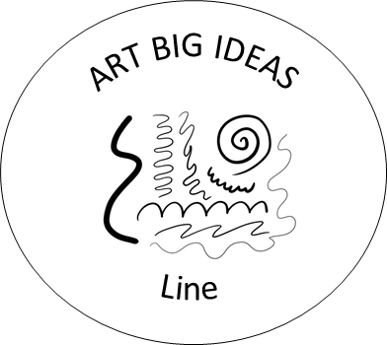 Line | A line is a mark that can be straight, curved, wavy or zig-zag. | Lines can be used to show movement, direction and detail. | Different lines can create texture, tone, depth and meaning in artwork.
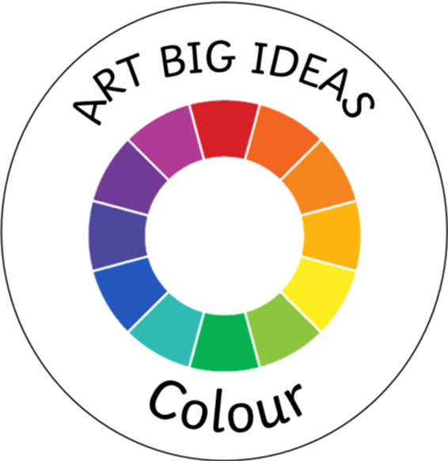 Colour | Colour helps us show what things look like and how they make us feel | Colours can be mixed and chosen to create different moods and effects. | Artists use colour purposefully to communicate ideas, feelings and atmosphere.
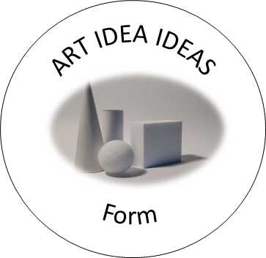 Form | Form is a shape that has height, width and depth, like a sculpture. | Forms are 3D objects that can be viewed from different angles. | Artists use form to create realistic, abstract or imaginative three-dimensional work.
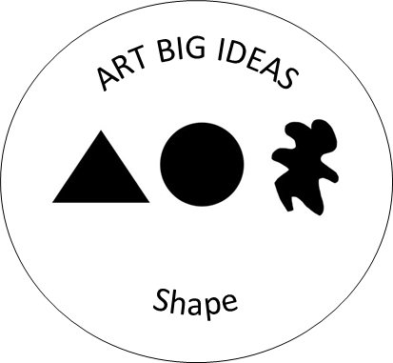 Shape | A shape is a flat area with an outline, such as a circle or square. | Shapes can be geometric or organic and help create pictures and designs. | Artists combine and arrange shapes to communicate ideas and compositions.
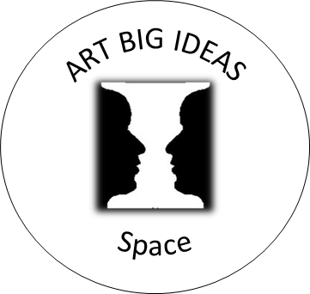 Space | Space is the area around, between and inside objects. | Space can make objects appear near, far, crowded or separate. | Artists use space to create depth, perspective and focus within artwork.
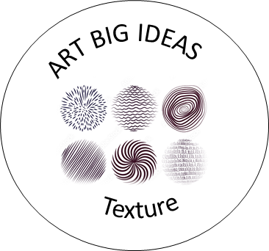Texture | Texture is how something feels or looks like it feels. | Texture can be created using different materials, marks and techniques. | Artists use texture deliberately to add detail, interest and realism.
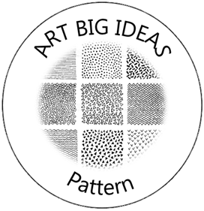 Pattern | A pattern is a design that repeats | Patterns are created by repeating shapes, colours, lines or images. | Artists use pattern to create decoration, structure, rhythm and meaning.

