Good Friday
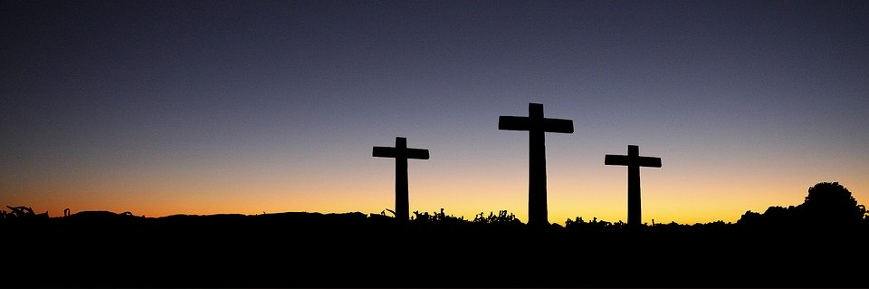

Talk about how we feel being separated from friends.
How did Jesus’ friends feel when they saw Him die on the cross on the first Good Friday?
Draw a face or write a few words about these feelings.
__________________________________
__________________________________
__________________________________
__________________________________
__________________________________
__________________________________

Can you crack the code?
A | B | C | D | E | F | G | H | I | J | K | L | M | N | O | P | Q | R | S | T | U | V | W
1 | 2 | 3 | 4 | 5 | 6 | 7 | 8 | 9 | 10 | 11 | 12 | 13 | 14 | 15 | 16 | 17 | 18 | 19 | 20 | 21 | 22 | 23

18,15,13,1,14,19 3,8,1,16,20,5,18 6,9,22,5 22,5,18,20,5 5,9,7,8,20.
23,8,9,12,5 23,5 23,5,18,5 19,20,9,12,12 19,9,14,14,5,18,29 3,8,18,9,19,20 4,9,5,4
6,15,18 21,19.
Why do you think we sometimes eat hot cross buns on Good Friday?
Easter Sunday

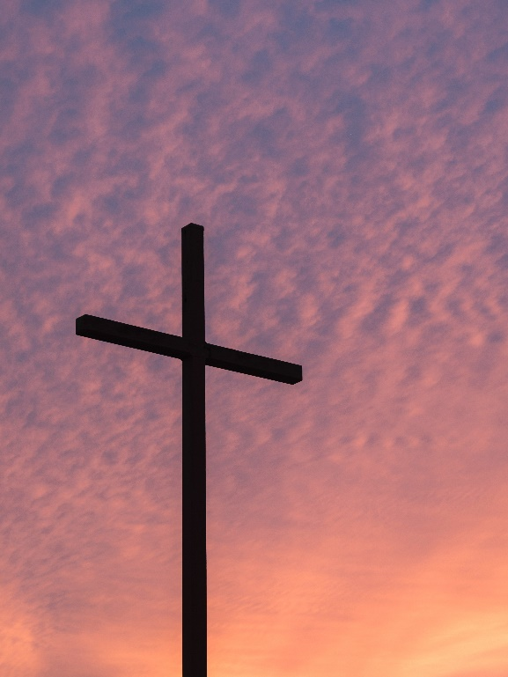
The tomb is empty- Jesus is risen.
How do Jesus’ friends feel now?
Draw a face or write some words to show how they feel.

Be a Codebreaker

A | B | C | D | E | F | G | H | I | J | K | L | M | N | O | P | Q | R | S | T | U | V | W
1 | 2 | 3 | 4 | 5 | 6 | 7 | 8 | 9 | 10 | 11 | 12 | 13 | 14 | 15 | 16 | 17 | 18 | 19 | 20 | 21 | 22 | 23

8,5 8,1,19 18,9,19,5,14

Why do we sometimes eat Easter eggs on Easter Sunday?

If someone asked you what the story of Easter was all about what might you say? (Draw some pictures if that helps!)

Easter Challenge – Can you find all the words in this puzzle?
S T A M R Y D I A R F A
T O P N R L R D H T C R
O M G E G E I A A Q G P
N B X A R E A B M G U G
E E A E S I L R U H M K
U V E X N U S P L R K J
H I Z C S F S E Y Y V Z
G L P I Q H G E N Y A D
X A L T A Q Y A J Q H Y
Q J U E T L G G E B D O
O A A D A E M U F I L G
D X U E R K Y X F X O Z

AFRAID
ALIVE
ANGEL
EARLY
EXCITED

JESUS
MARY
RISEN
STONE
TOMB

Easter Challenge – Can you find all the words in this puzzle? (It’s harder!)
D | E | R | E | D | L | I | W | E | B | Y | R | S | E | A
P | E | N | T | R | A | N | C | E | E | E | E | C | X | L
W | T | N | I | O | N | A | J | G | S | L | A | P | C | N
D | Z | L | A | C | K | M | Z | U | P | L | D | Q | I | T
T | N | C | G | M | C | O | R | I | V | G | E | G | T | U
K | D | P | D | N | E | R | C | A | O | P | I | R | E | R
S | Y | S | M | Y | E | S | R | M | J | Z | F | G | D | I
V | A | Y | R | C | I | Y | H | G | M | P | I | W | O | O
D | O | B | T | D | X | N | J | T | O | X | C | M | S | Y
P | F | I | B | M | H | F | S | B | E | K | U | J | A | A
F | O | I | F | A | Q | Y | N | Q | L | G | R | L | O | M
N | N | U | B | L | T | E | H | G | X | Z | C | P | I | A
Z | A | J | J | Z | F | H | J | Q | L | D | S | R | L | B
N | T | S | A | T | C | D | N | Y | P | Q | I | W | W | W
S | X | N | P | Q | A | R | B | S | Q | R | T | U | E | E

Sabbath
Anoint
Entrance
Resurrection
Crucified
Disciples
Bewildered
Excited
Calvary
Gethsemane

